## horizontal line



Remote Calculator

Sprint Implementation

**Timeline:11.10.2022-19.10.2022**

Group 6

# 

# INDEX

|  |  |  |
| --- | --- | --- |
| **SL. NO.** | **CONTENTS** | **PAGE NO.** |
| 1 | Overview. . . . . . . . . . . . . . . . . . . . . . . . . . . . . . . . . . . | 2 |
| 2 | Goals. . . . . . . . . . . . . . . . . . . . . . . . . . . . . . . . . . . . . . . | 2 |
| 3 | Design overview. . . . . . . . . . . . . . . . . . . . . . . . . . . . .  Dataflow diagram level 0. . . . . . . . . . . . . . . . . .  . . . . . . . . . . . . . . . . . .  Flowchart for Remote Calculator. . . . . . . . . . .  Flowchart for Client Side. . . . . . . . . . . . . . . . .  Flowchart for Server Side . . . . . . . . . . . . . . . . . | 3  3  4  5  6  7 |
| 4 | System architecture. . . . . . . . . . . . . . . . . . . . . . . . . | 8 |
| 5 | Functions . . . . . . . . . . . . . . . . . . . . . . . . . . . . . . . . . . |  |
|  |  |  |
|  |  |  |

# 

# 1. Overview

It is an project about remote calculator using socket programming. It takes input from the client as operators, operands and number of operands and evaluate the entered expression on the server side and display the result on the client side.

# Goals

This project aims at creating a calculator that first authenticate the user using username and password. Later it should take input from the client such as number of operands along with operand and operators separated by “ ; ”.

# Design Overview

## 

## 3.1. Data Flow Diagram Level 0(LLD):

 Remote Calculator

Server Client

Username operations are Results are fetched

Password performed from the server

## 

## 3.2. Flowchart for Remote Calculator:

Connection b/w Client & Server

Performs Operation in server

Exit or Disconnected

Send the Result to the client

Take the inputs from client

If login is successful

Inputs like no of arguments, no of operations etc

**YES**

**NO**

## 

## 

## 

## 3.3. Flowchart for Client Side:

Client Side

Connection established With Server

Provide inputs

If login is successful

Exit or Disconnection

Result

Inputs like no of arguments, no of operations etc

**NO**

**YES**

## 

## 

## 

## 

## 3.4. Flowchart for Server Side:

**Server side**

Connection with Client

Perform Operations

Exit or Disconnected

Send the Result to the client

Take Inputs from client

If login is successful

Inputs like no of arguments, no of operations etc

**YES**

**NO**

## 

# System Architecture:

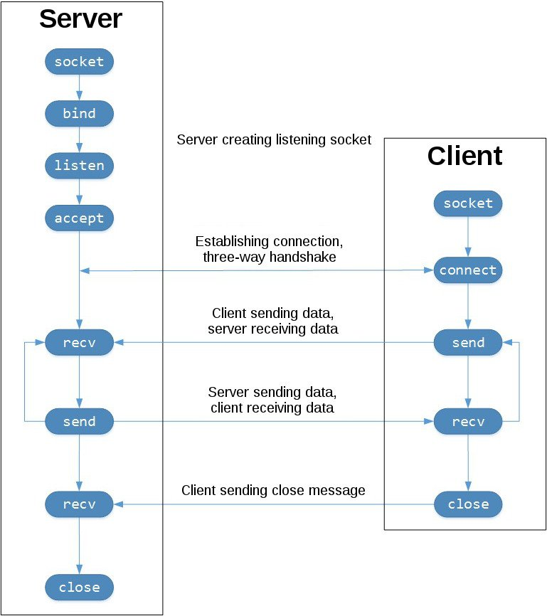

# 5. Functions:

### **5.1. Server Side:**

Here first it will create a connection with client and perform multiple task like taking inputs from client side such as number of operands and operators separated by ” ; ”.

#### 5.1.1. login Functionality:

This function will authenticate the user whether it is eligible to access it or not using a username and password.

#### 5.1.1. Input number of operands:

#### This will take the total number of operands followed by the operands itself separated by ” : “ as input.

#### 5.1.1. Input number of operators:

After the operands are given then this function will ask for the operators separated by “ ; “.

#### 5.1.1. Formulate the expression:

This function create the required expression to be solved using the given inputs.

#### 5.1.1. Perform the calculations:

This function will finally evaluate the expression and show result to the client.

### **5.2. Client Side:**

This functionality will do the following tasks…

#### 5.2.1. Give inputs:

This function will take all the inputs from client and provide it to the server.

#### 5.2.2. Fetch the Result:

This function will show the final evaluated result.